**Filte-**

A **filter** is an object that is invoked at the preprocessing and postprocessing of a request.

It is mainly used to perform filtering tasks such as **conversion, logging, compression, encryption and decryption, input validation etc.**

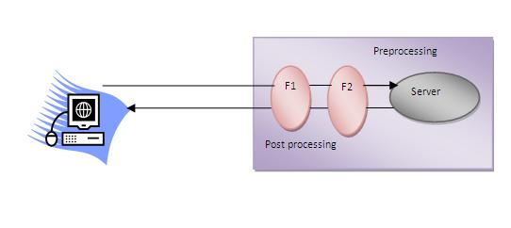

The **servlet filter is pluggable**, i.e. its entry is defined in the web.xml file, if we remove the entry of filter from the web.xml file, filter will be removed automatically and we don't need to change the servlet.

Usage of Filter

* recording all incoming requests
* logs the IP addresses of the computers from which the requests originate
* conversion
* data compression
* encryption and decryption
* input validation etc.

Advantage of Filter

1. Filter is pluggable.
2. One filter don't have dependency onto another resource.
3. Less Maintenance